Feature selection results for exp_10_part_1 and Nmin = 10

1. result: (pp1, pp4, peak_frequency)
Estimated Epsilon: 0.086444, Picked Epsilon: 0.096444, MinNumPoints: 10
DBCV index value: 0.7372
cluster -1 had 0% single peaks
cluster 1 had 100% single peaks
cluster 2 had 0% single peaks
cluster 3 had 0% single peaks
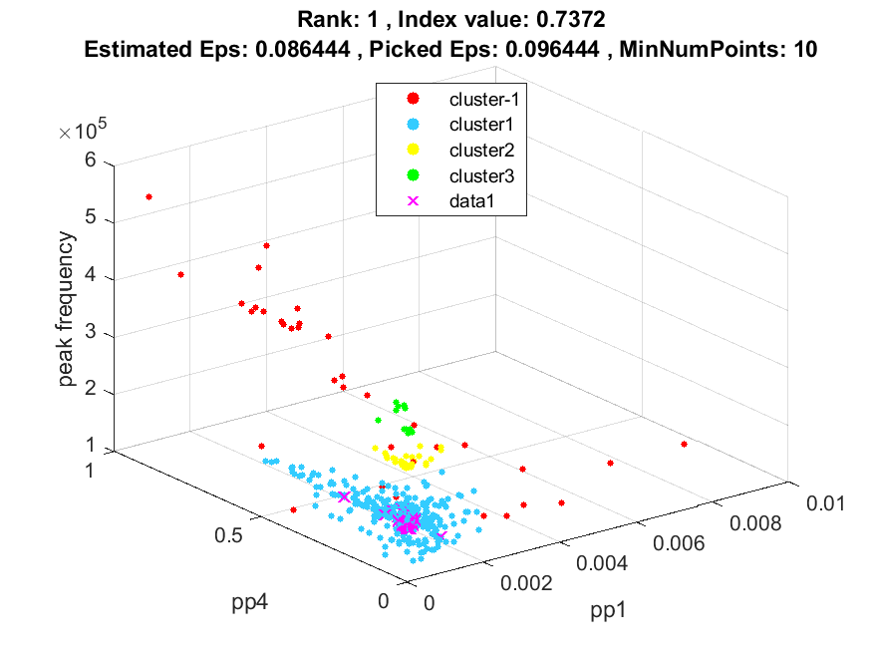
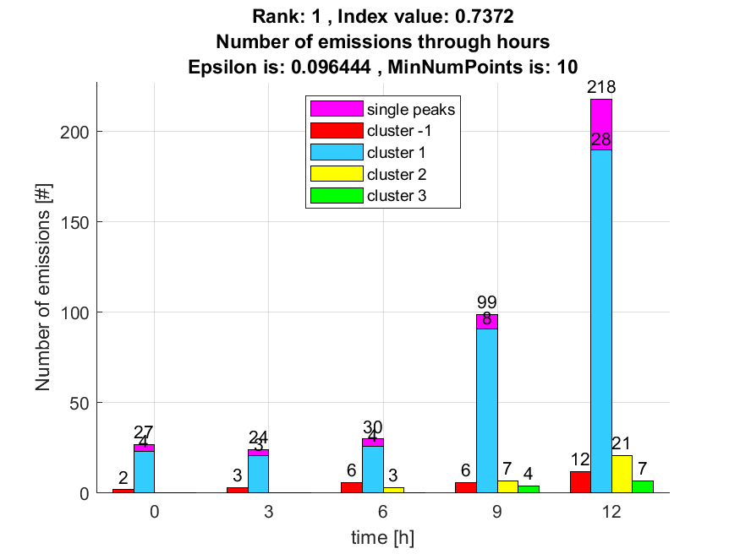

2. result: (pp1, peak_frequency, amp_of_peak_frequency)
Estimated Epsilon: 0.056907, Picked Epsilon: 0.066907, MinNumPoints: 10
DBCV index value: 0.71537
cluster -1 had 21.2766% single peaks
cluster 1 had 78.7234% single peaks
cluster 2 had 0% single peaks
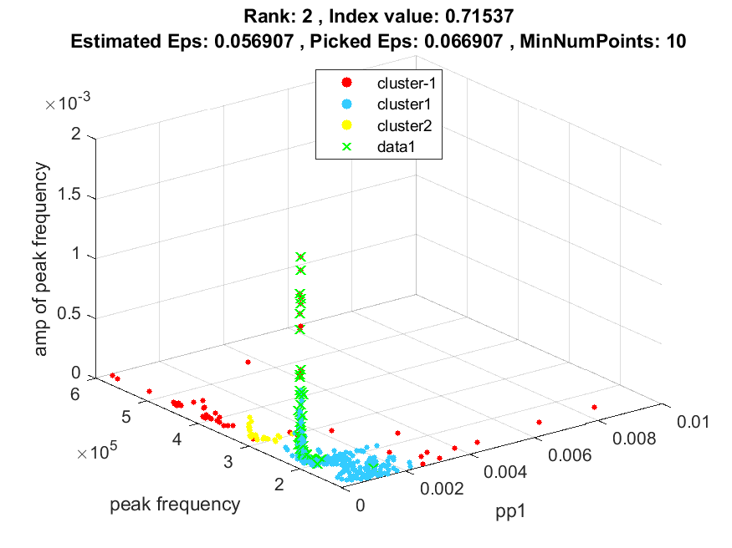
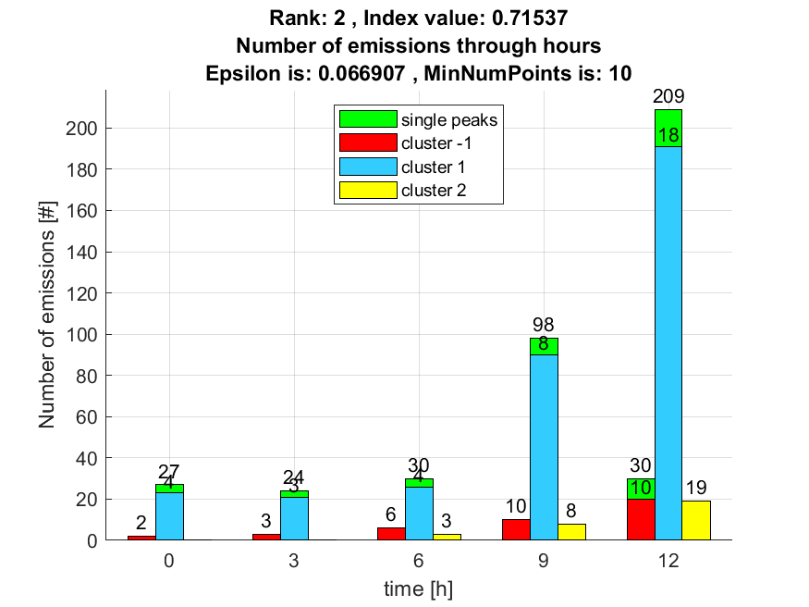

3. result: (signal_strength, pp4, peak_frequency)
Estimated Epsilon: 0.067135, Picked Epsilon: 0.077135, MinNumPoints: 10
DBCV index value: 0.70762
cluster -1 had 14.8936% single peaks
cluster 1 had 85.1064% single peaks
cluster 2 had 0% single peaks
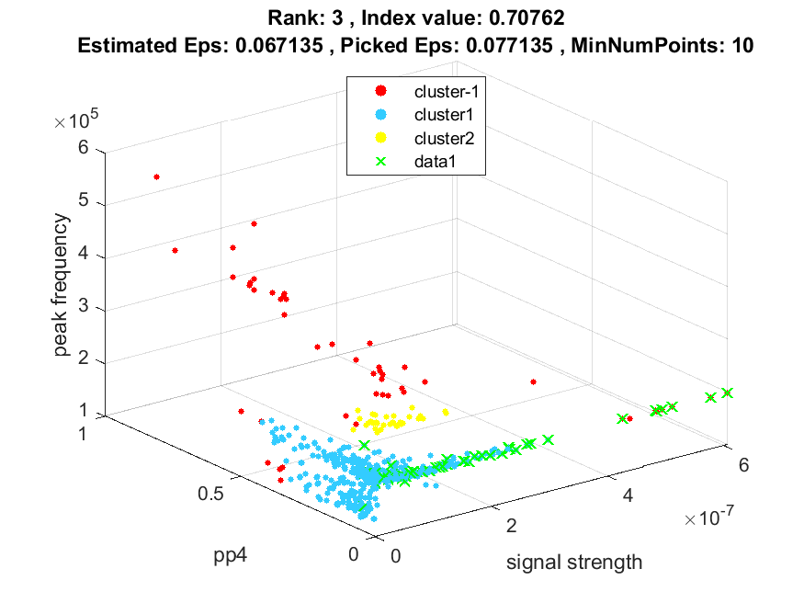
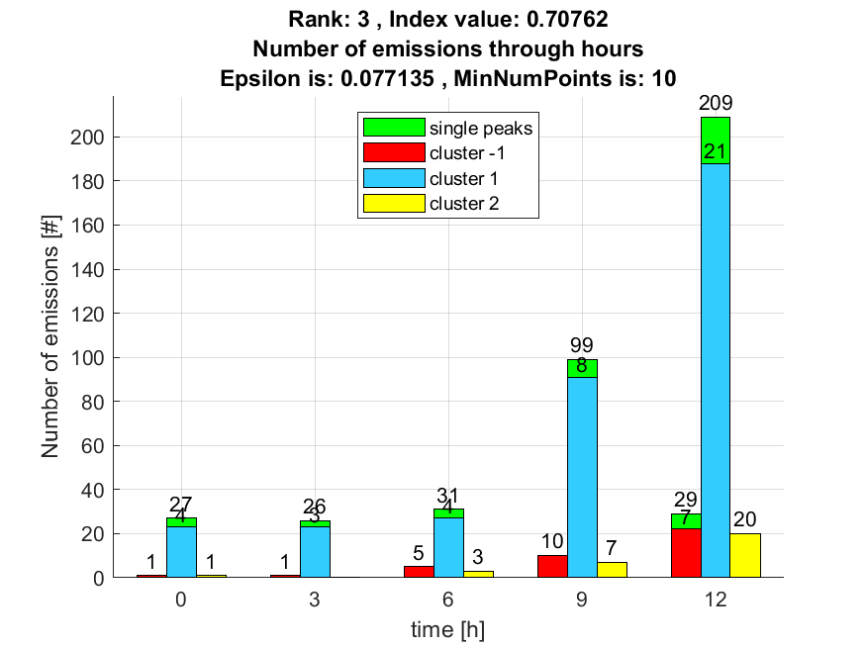

4. result: (counts_from, pp1, peak_frequency)
Estimated Epsilon: 0.09534, Picked Epsilon: 0.10534, MinNumPoints: 10
DBCV index value: 0.7073
cluster -1 had 0% single peaks
cluster 1 had 100% single peaks
cluster 2 had 0% single peaks
cluster 3 had 0% single peaks
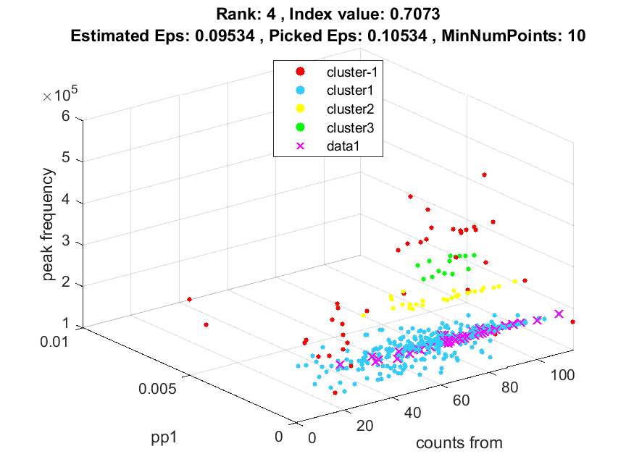
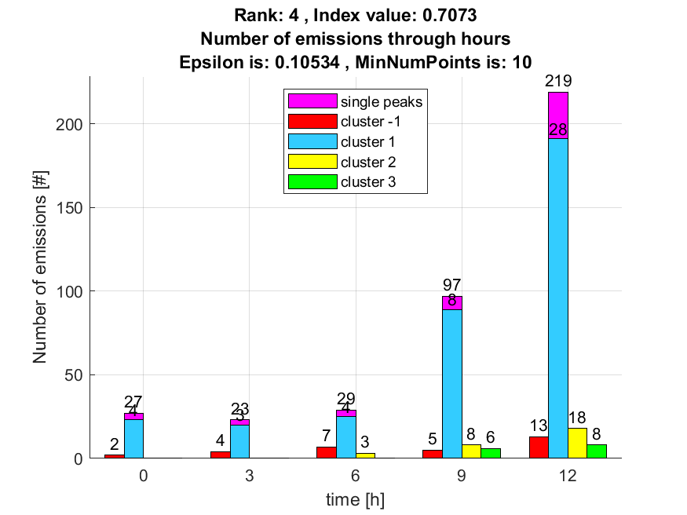

5. result: (signal_strength, pp1, peak_frequency)
Estimated Epsilon: 0.055615, Picked Epsilon: 0.065615, MinNumPoints: 10
DBCV index value: 0.70703
cluster -1 had 17.0213% single peaks
cluster 1 had 82.9787% single peaks
cluster 2 had 0% single peaks
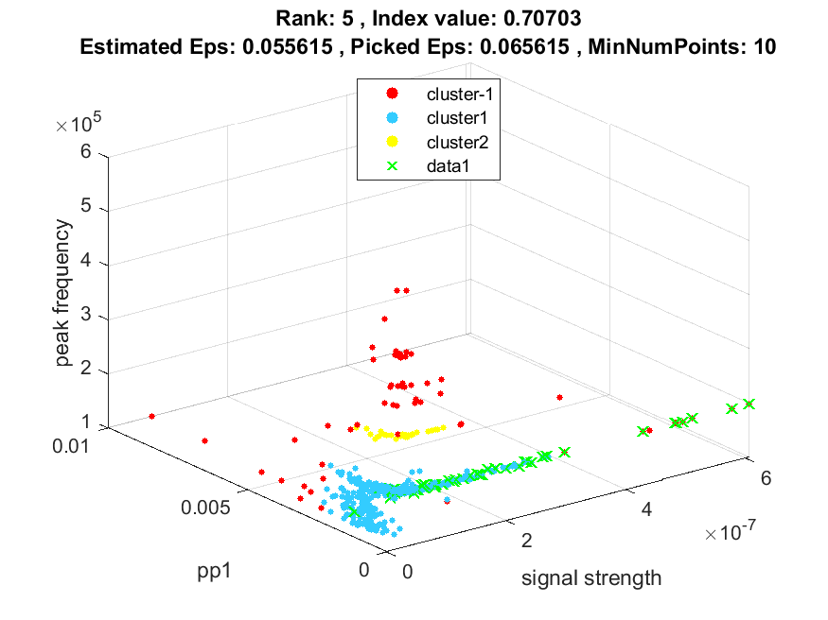
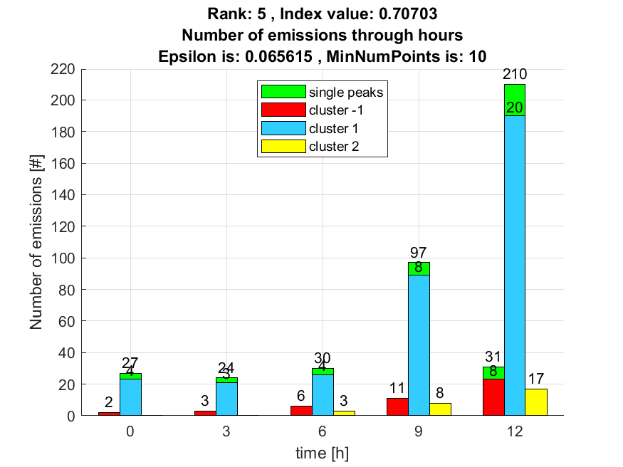

6. result: (rise_time, pp1, peak_frequency)
Estimated Epsilon: 0.088938, Picked Epsilon: 0.098938, MinNumPoints: 10
DBCV index value: 0.70564
cluster -1 had 0% single peaks
cluster 1 had 100% single peaks
cluster 2 had 0% single peaks
cluster 3 had 0% single peaks
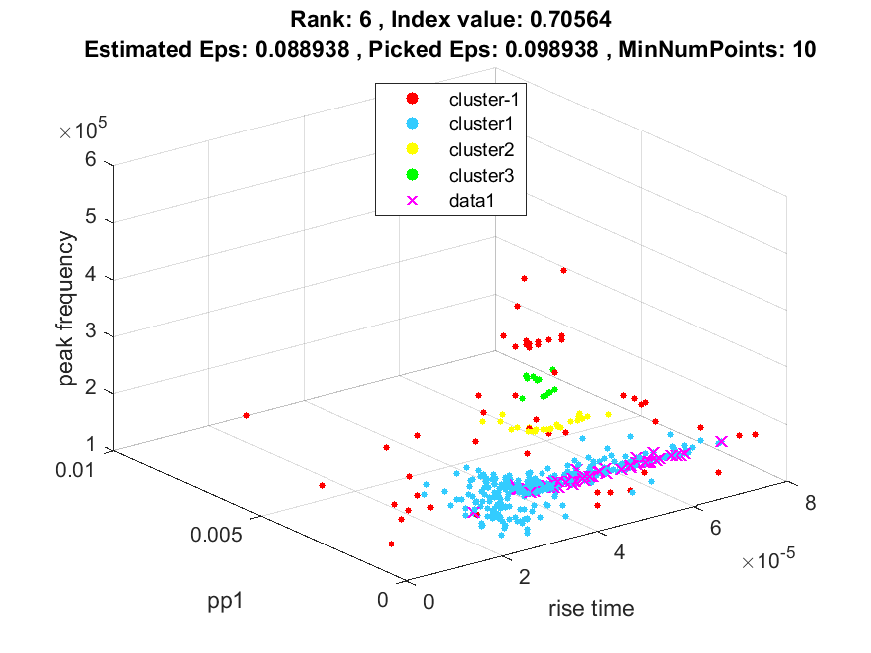
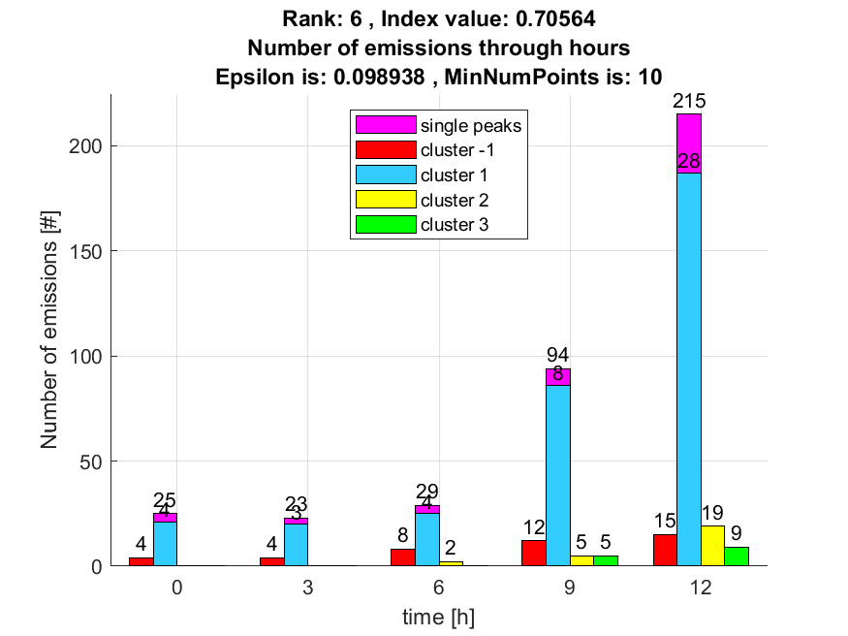

7. result: (pp4, peak_frequency, amp_of_peak_frequency)
Estimated Epsilon: 0.066108, Picked Epsilon: 0.076108, MinNumPoints: 10
DBCV index value: 0.70159
cluster -1 had 21.2766% single peaks
cluster 1 had 78.7234% single peaks
cluster 2 had 0% single peaks
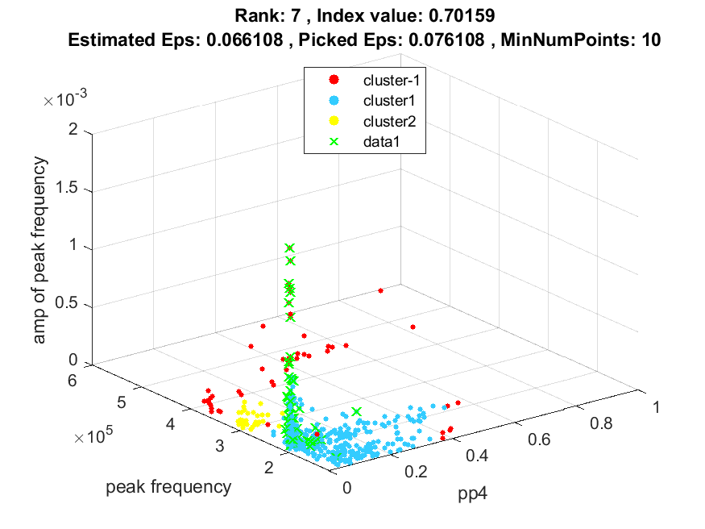
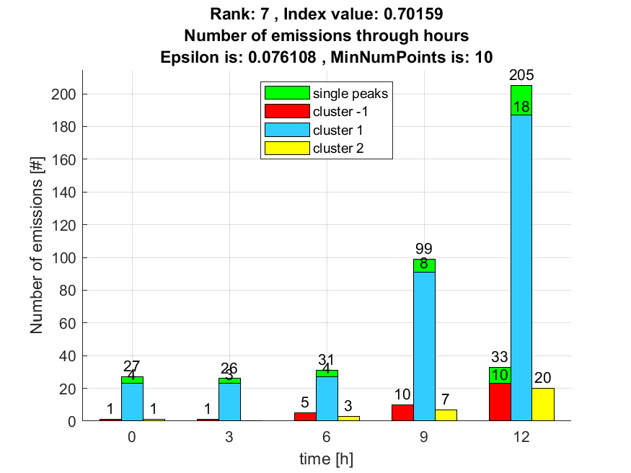

8. result: (pp4, centroid_frequency, peak_frequency)
Estimated Epsilon: 0.08527, Picked Epsilon: 0.09527, MinNumPoints: 10
DBCV index value: 0.70153
cluster -1 had 0% single peaks
cluster 1 had 100% single peaks
cluster 2 had 0% single peaks
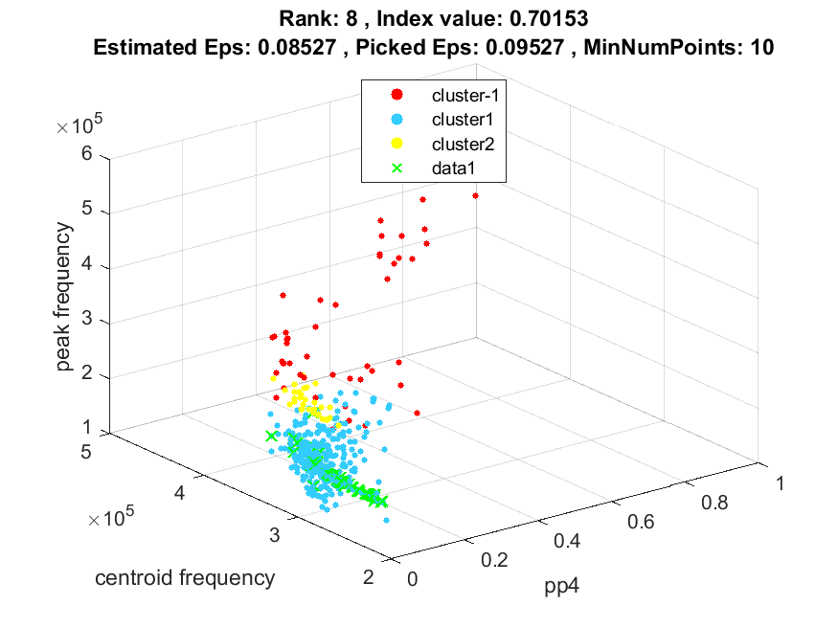
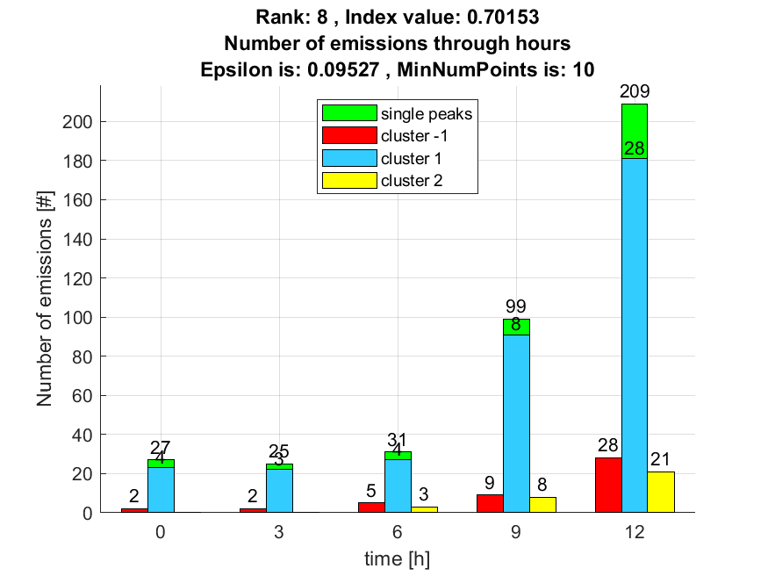

9. result: (peak_amplitude, pp1, peak_frequency)
Estimated Epsilon: 0.05772, Picked Epsilon: 0.06772, MinNumPoints: 10
DBCV index value: 0.69553
cluster -1 had 14.8936% single peaks
cluster 1 had 85.1064% single peaks
cluster 2 had 0% single peaks
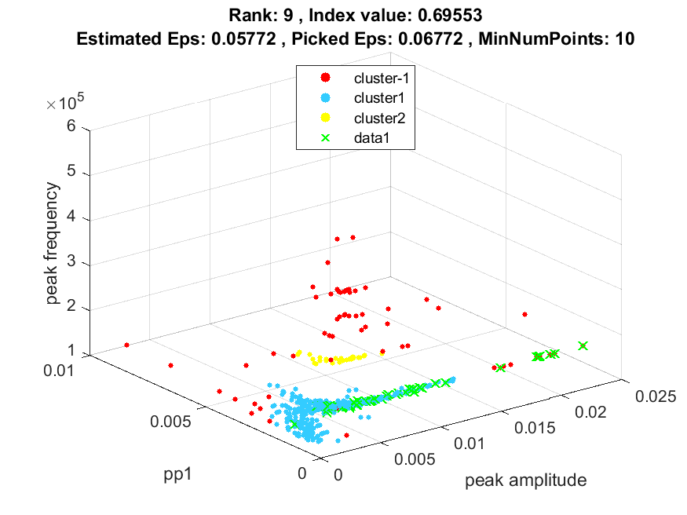
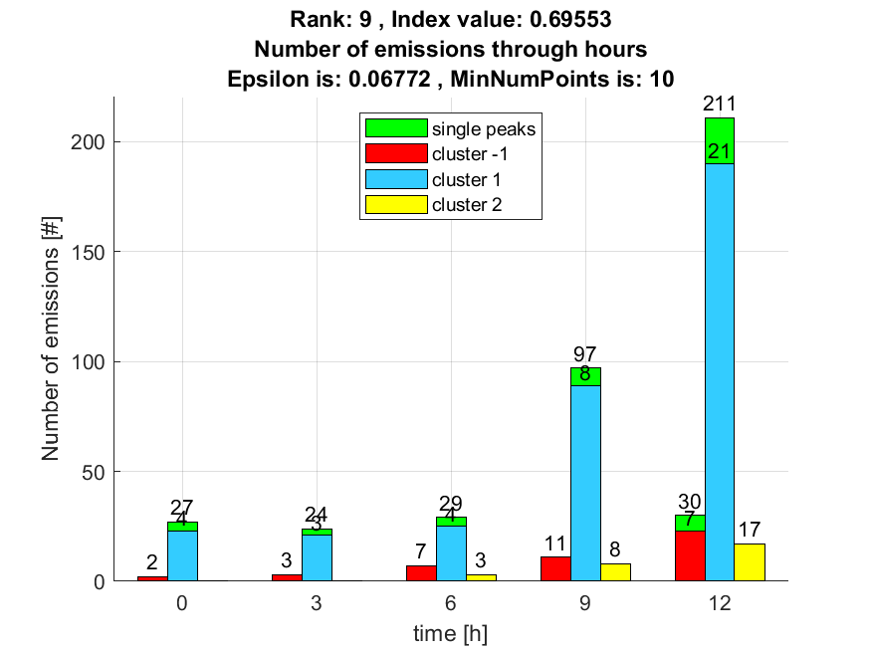

10. result: (pp1, centroid_frequency, peak_frequency)
Estimated Epsilon: 0.092958, Picked Epsilon: 0.10296, MinNumPoints: 10
DBCV index value: 0.69098
cluster -1 had 0% single peaks
cluster 1 had 100% single peaks
cluster 2 had 0% single peaks
